**CSA1518-CLOUD COMPUTING**

V.Mrudula

192011395

**Expt:11**

Change Hardware compatibility of a VM (Either by clone/create new one) which is already created and configured.

**IMPLEMENTATION:**

STEP 1: GO TO VM AND GO TO MANAGE AND CLICK CLONE

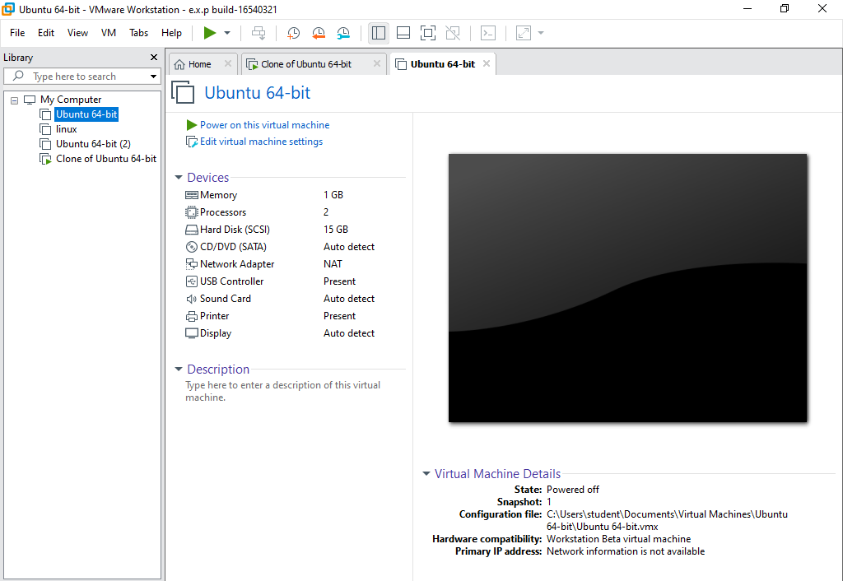

STEP 2:CHANGE ANY CONFIGURATION

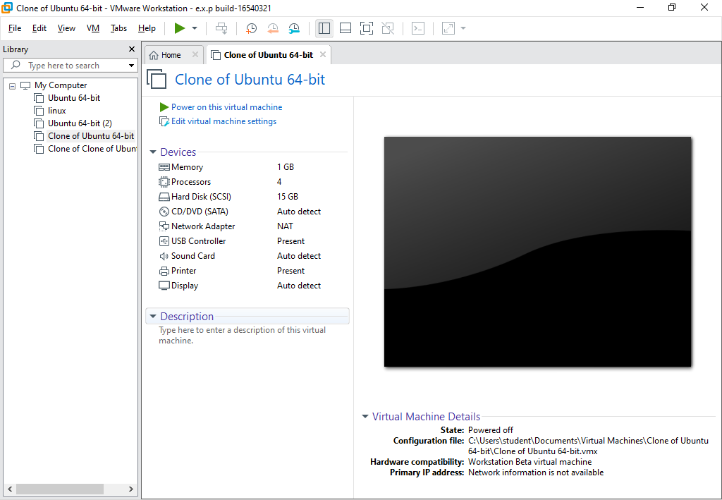

STEP 3:CLICK ON MANAGE AND CLONE

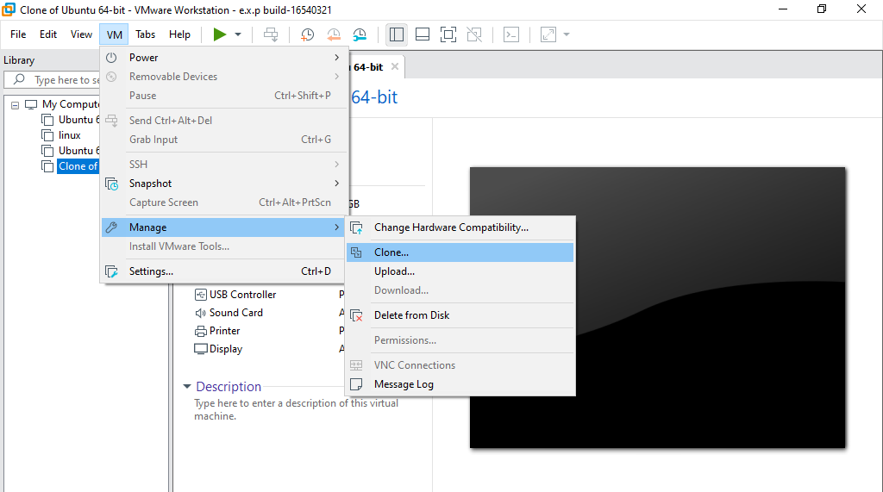

STEP 4:SELECT CLONE SOURCE

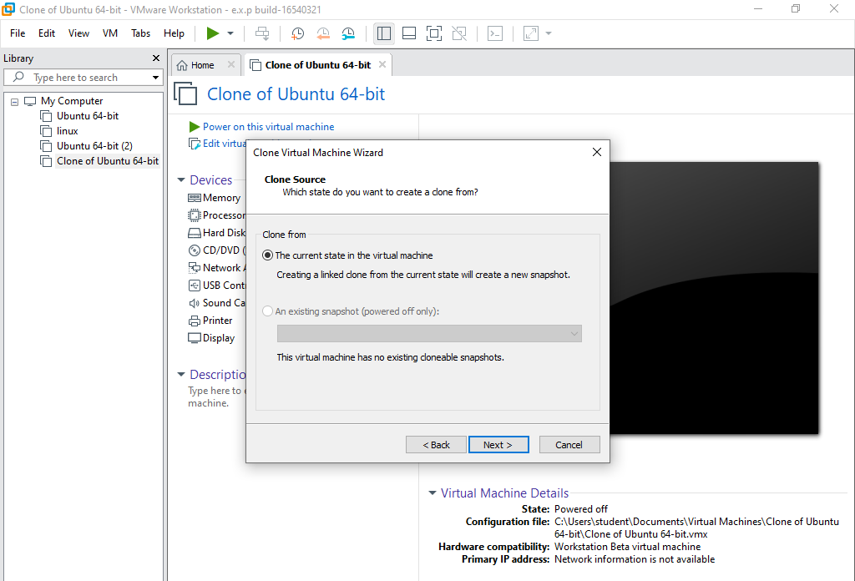

STEP 5:SELECT CLONE TYPE

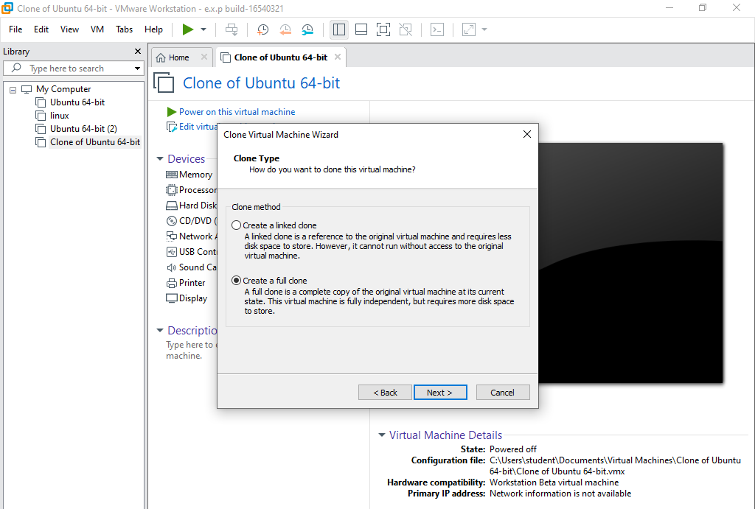

STEP 6: GIVE VIRTUAL MACHINE NAME

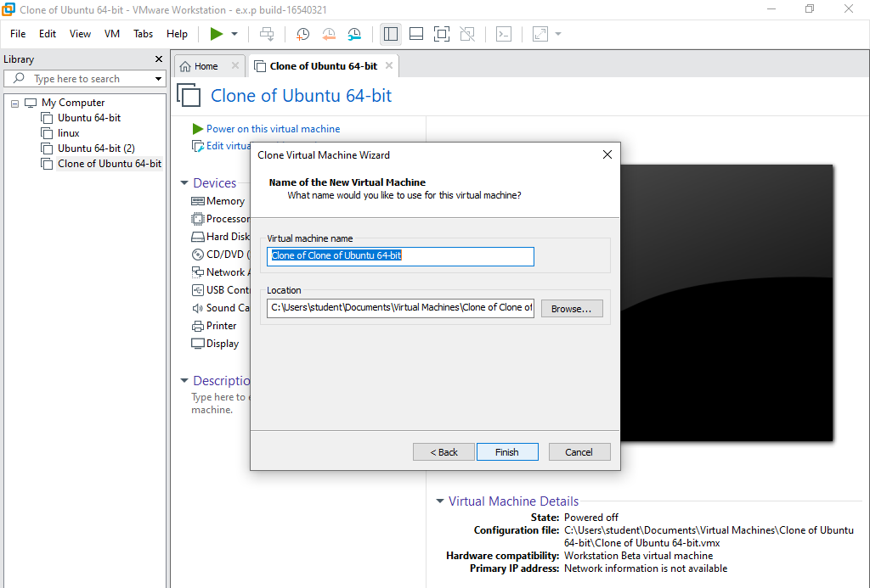

STEP 7:POWER ON VIRTUAL MACHINE

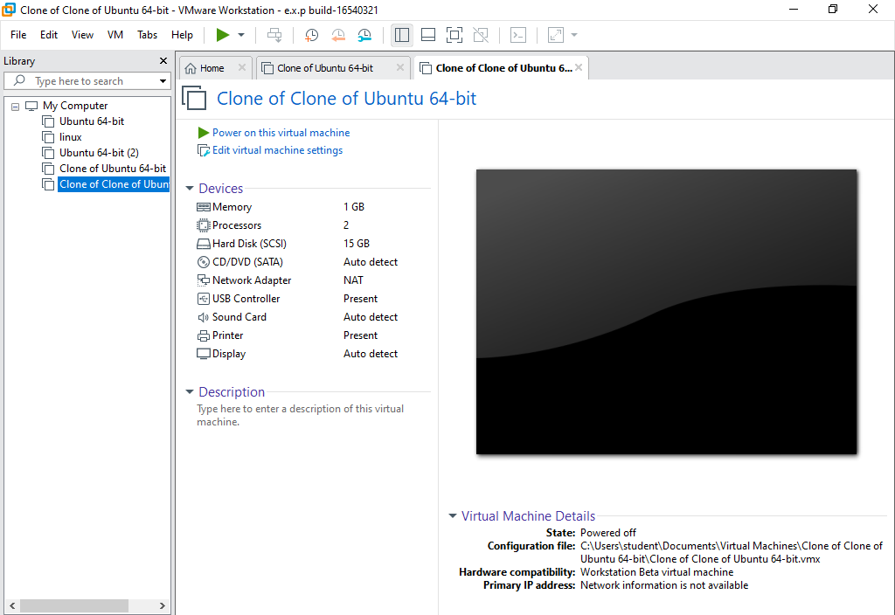

STEP 8:OUTPUT

